**Student:** Aluizio Diniz Neto **Number:** 3001825

**THE EXTREME BOAT GAME**



Experience the thrill of fishing and intense water battles in The Extreme Boat Game, an immersive action game that will test your skills, reflexes, and strategic thinking. Prepare to embark on a captivating journey beneath the shimmering waves as you cast your line, fend off deadly foes, and confront a legendary boss lurking in the depths.

**Features:**

**Seamless Sea Navigation:** Seamlessly navigate through the open sea by simply clicking on the water, allowing you to effortlessly explore the expansive underwater landscapes.

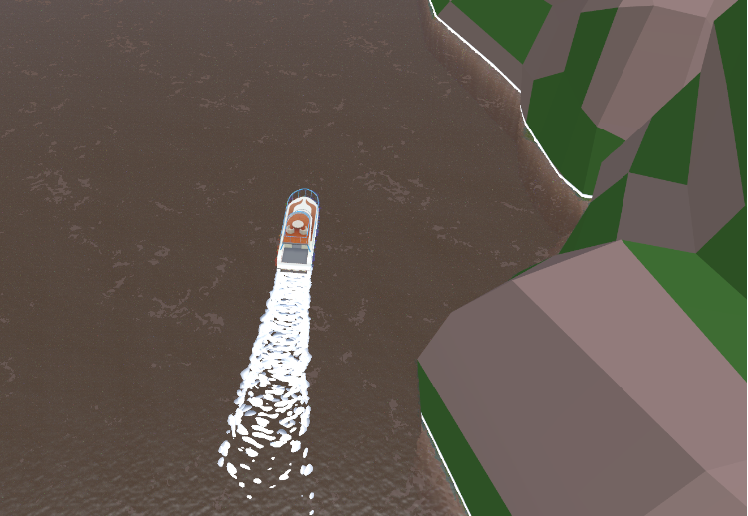

**Master the Art of Fishing:** Explore a vast and visually stunning underwater world teeming with exotic marine life. Cast your line, reel in the catch of the day, and collect valuable resources.

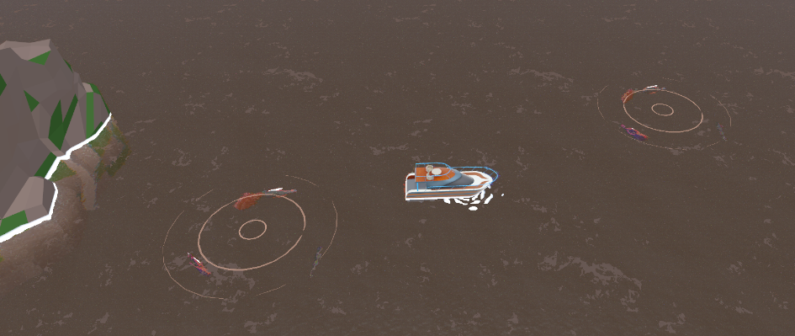

**Unleash Destruction:** Encounter fierce adversaries like bloodthirsty sharks and menacing sea creatures. Arm yourself with a powerful cannon to shoot and get these enemies out of your way.

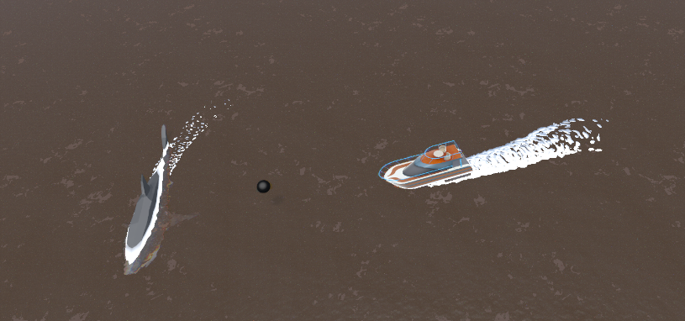

**Conquer the Abyss:** Dive deeper into treacherous waters and face the ultimate challenge—a colossal boss lurking in the darkest depths. Test your mettle and devise clever strategies to overcome this fearsome adversary, harnessing all your skills and equipment to emerge victorious.

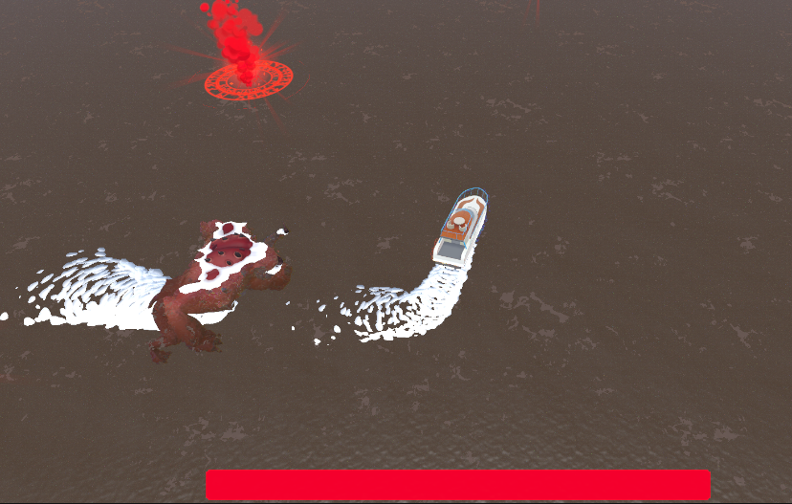

**GitHub**

https://github.com/aluiziod/GameDevelopment_Repository

**Video Link on OneDrive**

[Aluizio_Diniz_3001825_Trailler.mp4](https://griffithcollege628-my.sharepoint.com/:v:/g/personal/aluizio_dinizneto_student_griffith_ie/EVgO8iw-vNdLnov2JWcAwIQB51-SQ0oc2xrjIN8oGKGtWQ?e=JorNKn)

**Download Project link:**

[GameDevelopment_Repository.zip](https://griffithcollege628-my.sharepoint.com/:u:/g/personal/aluizio_dinizneto_student_griffith_ie/EVf7ds1ns1NFqoMkYJ88sOUBRD-xc_ntTa17dIJ8gZCvTg?e=WigFNj)